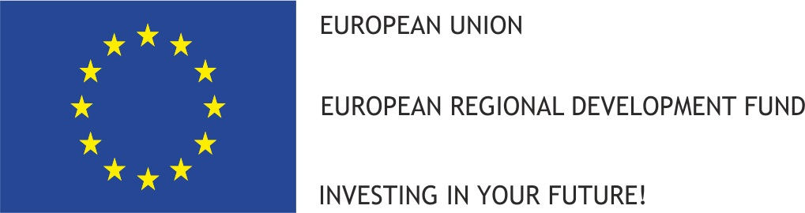

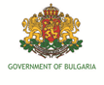

Thematic meeting for the beneficiaries of projects
financed under the INTERREG V-A Romania – Bulgaria Programme

19th of November 2019, Giurgiu, Romania

Meeting Room of Chamber of Commerce, Industry and Agriculture Giurgiu

Giurgiu, Aleea CFR

CONFIRMATION FOR PARTICIPATION

Institution:

Name:

Surname:

Position:

Telephone number:

Fax:

E-mail:

Please send the confirmation for participation to the following e-mail address: jsrobg@calarasicbc.ro, until 14th of November 2019. Thank you!

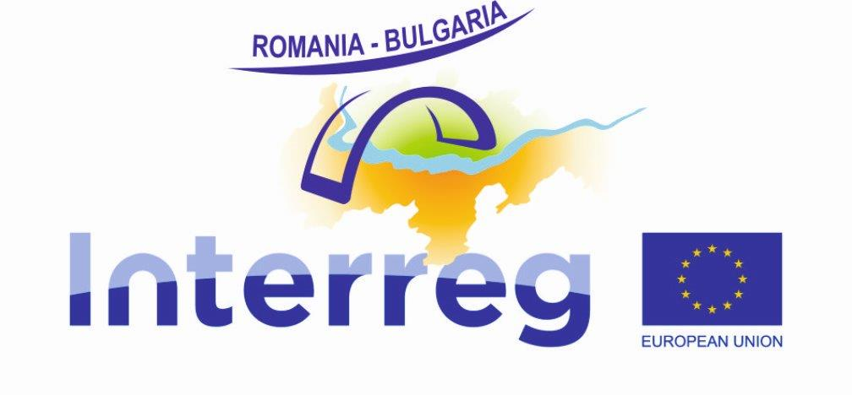

__________________________________________________________________________________
A request to attend this thematic meeting means that certain personal data concerning each participant will have to be handled by the Cross Border Cooperation Regional Office Calarasi for the Romania-Bulgaria border in its capacity of Joint Secretariat for the Interreg V-A Romania-Bulgaria Programme, in conformity with Regulation (EC) 45/2001. By registering, a participant gives his or her agreement for this personal data to be used in the context of the meeting.

www.interregrobg.eu

